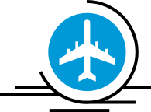
A week in one of the most beautiful cities in the world
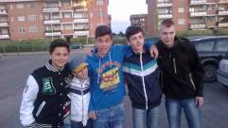
On the 20th of May we flew to Italy. It was my first flight.
At 2 p.m. we landed at the airport and then we went to the hotel where our families were waiting for us. It turned out that my Italian friend Lorenzo had a friend Daniele with whom my Polish friend Michał lived.
I, Lorenzo, Michał, Daniele and Daniele’s brother
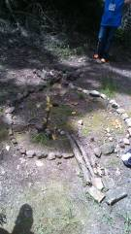
On the second day we went to their school, we watched the lessons. Later the Italian students welcomed us with a play “Pinocchio”, which they prepared especially for us. In the afternoon we ate traditional Italian meals. It was pasta, of course.
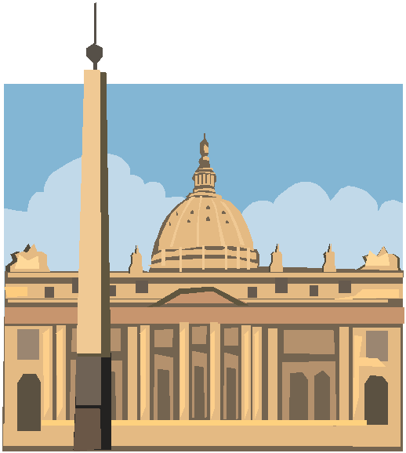On the third day we went to the park where we made a compositions from things we could find there: stones, leaves, sticks, pine cones and flowers. Then we wrote poems about them. After that we went to a concert of school’s orchestra. It was a very hard-working but nice day.
Our composition
On the fourth day we went to a Vatican City and to the Vatican Museum. Then we were on St. Peter’s Square where we had some free time. It was a very important visit to me because I could see a place where John Paul II was a pope for many years. In the evening me and my Italian friend went on his friend's birthday party.
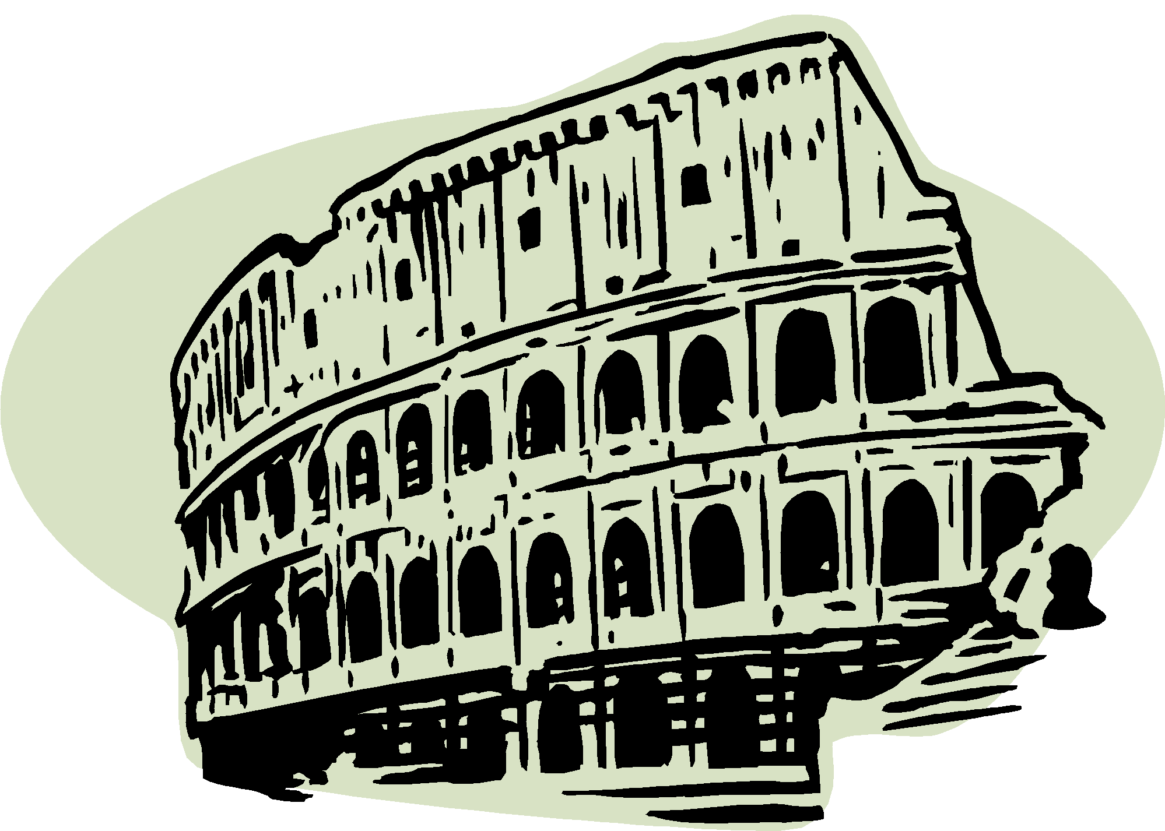On the fifth day we were in Rome and we saw the Coloseum, Fontana di Trevi and other monuments. Then there was an official "goodbye party" for Comenius people.
In the evening I was invited by my Italian family to a traditional Italian restaurant where we ate a pizza. It was the best pizza I have ever eaten.
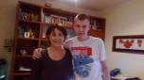
On the sixth day we arrived to Ostia. It was a very interesting experience because I heard about Ostia on my history lessons. The atmosphere there was very pleasant. Then we went to the beach. In the evening me and my Italian friends watched the final of Champions League as they are great fans of football.
The next day, in the morning we went to the airport. Our Italian families came to see us off . We were back to Poland again at 2 p.m.
I and Lorenzo’s mother

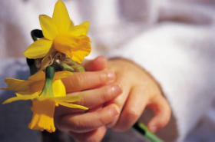
It was a very interesting visit for me, I could not only check my English but also I had the opportunity to practice it. I hope, me and Lorenzo will be friends in the future. I want to thank to Lorenzo, his mother, his father and Mrs Rafaella which is coordinator for Italy. I hope their visit and staying in Poland will be as good as mine.
by Patryk Sobczyk

