Nr 1

OCTOBER/NOVEMBER 2012

FOREVER FRIENDS

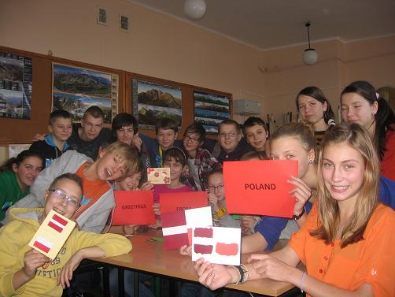

LOWER SECONDARY SCHOOL IN KIJE
POLAND

COMENIUS 2012 - 2014

CONTESTS:

- The Voices from the Land – about the Comenius project ……………………………………. 4
- The first visit in Turkey 05.11.12 - 11.11.2012 – an interview ……………………………… 5
- National Independence Day - 11th November …………..……………………………………….. 7
- Teachers’ Day - 14th October……………………………………………………………………….………. 8
- Christmas is coming …………………………………………………………..................................... 9
- English idioms and idiomatic expressions …………………………………………………………. 10
- Just kidding ……………………………………………………………………………………………………….. 11
- Coming in the next issue…………………………………………………………………………………….. 12

Editorial team: Gabriela Pytel, Ewa Moskwa, Klaudia Pola, Aleksandra Olejnik, Wiktoria
Piotrowska, Julia Sternak, Inga Łukawska, Wiktoria Fatyga, Patrycja Fatyga,
Karolina Wrzoskiewicz, Wiktor Blicharski, Ernest Powałka, Jakub
Jabłczyński, Dawid Jakubczyk, Szymon Gawior, Michał Wolny, Konrad
Madej, Michał Skubek

Chief editor: Mrs Aneta Palińska

Dear Friends !
Coming back to school after the long summer holidays is always a painful experience for us. Unfortunately, it’s a high time to get down to some studying. However, this year the return isn’t so difficult because our school has just started cooperation with foreign schools as a part of Comenius project. The students who take part in the project will be able to go to the following countries : Spain, Italia, Latvia, Turkey and Romania. They will meet new friends and get to know different cultures.

by Klaudia Pola



1. The Voices from the Land – about the Comenius project

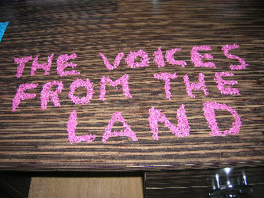
Comenius is a part of the EU’s Lifelong Learning Programme that focuses on all levels of school education. The programme aims to help young people and educational staff to increase the mobility across the EU, improve language skills and acquire the basic life competences necessary for persona development.
Our project The Voices from the Land metaphorically tells us about temporality of life. It celebrate oral and written language of art, performance and human imagination and it gives each person a chance to be a gifted orator, artist, listener and performer. We have agreed that there are five steps that have to be done:
- Explore a natural site. Find a place that “speaks” to you and your group.
- Find and play with natural materials. Give everyone permission to experiment. Create art. You can use leaves, grass, stone, twigs, sand, ice, snow, mud to create your art.
- Use your art to play with words. Create poetry.
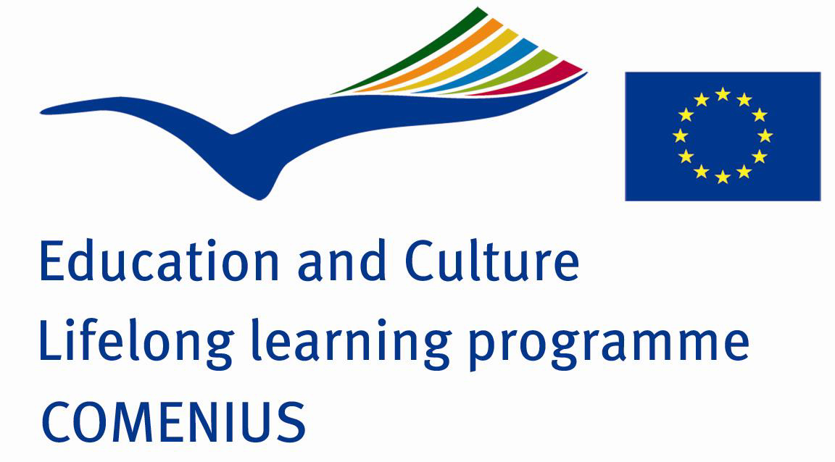
- Make your poetry come alive through performance.
- Design a Voices book and/or a Voices poster.
Are you ready to begin?

by Mrs Aneta Palińska
The first visit in Turkey 05.11.12 - 11.11.2012 – an interview

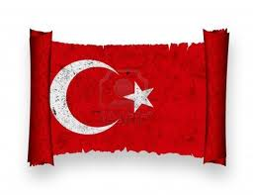
On 05.11.12 – 11.11.12 our school coordinator of the Comenius project – Mrs Aneta Palińska and the other English teacher Mrs Regina Boksa took part in the first meeting in Turkey. We are curious about all the details of the meeting so we have prepared some questions to the project coordinator.
- Were you afraid of the visit in Turkey?
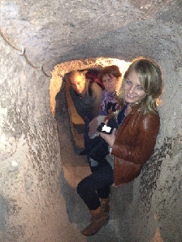
Our coordinator during the first project meeting in Turkey.

A little bit. It was the first meeting when I could see our project partners. I did not know
what to expect. But when I met our friends at the airport I knew that everything was OK.
- Can you give the names of the other school coordinators without hesitation☺?
Of course I can. Duygu from Turkey, Silvia from Spain, Raffaela from Italy,
Alesja from Latvia and Ana from Romania. Have I just passed a test? ☺
- Yes, brilliantly. We are curious about the Turkish school you have already visited.
Where is the school located?
Cumhuriyet Ilkogretim Okulu is located in Kırşehir, a small and a very beautiful town in central Turkey.
- Is it a big school? How many students are there in the school?
Yes, the school is really big. The staff number of the school is 128 and the pupils nearly 2400. They have classes from 1 to 8 grades. The students are 7 to 15 years old.
- How did you spend your time in Turkey?
It was a busy week. Every day we took part in different project activities. W showed our country, town and school power point presentation that we had prepared earlier in Poland. As you know we choose our project logo (1*) and anthem (2*). We also agreed on the dates of the next meetings.
- What are your impressions of Turkey? Did you like it?
Turkey is a unique country and it is certainly worth a visit.
- Did you notice any differences between our country and Turkey?
I have noticed a lot of differences. The most essential is religion. Turkish people are mainly Muslims. The mosques and the characteristic way of wearing are something unusual for us.
- How do You evaluate your entire trip?
The trip and the time I have spent with our Comenius friends were amazing. All Turkish people were friendly and nice. Our project coordinator Duygu Koca prepared the meeting perfectly. I would like to say thank you to all our Turkish friends.
by Patryk Sobczyk and Michał Wolny

COMENIUS 2012 – 2014

*Our Polish anthem proposal: *Our Polish logo proposals:
I

by Szymon Gawior

I used to live in my small place
I was alone and had no face
But one day I met my friends
Who changed my life and were my chance
II
So come my mate and spell your name

by Julia Sternak

by Julia Sternak 1

And give me a hand to do the same
Because I know you shares my dream
Of sky of blue and grass of green

Ref:

by Gabrysia Pytel

We don’t live in the heartless, dirty place
Full of dying lakes, we all are against
We all know that Comenius gives a chance
To work as one my friends
To find the nature heart

Our Project logo – prepared by Italian Partners
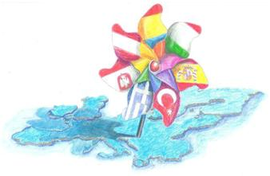

National Education Day
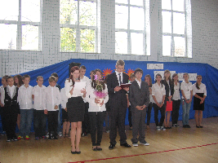
called the Teachers’ Day
14th October
14th October is always a big event in our school. We celebrate a teacher’s day every year. Our students under the supervision of Mrs Małgorzata Gawior have prepared a fantastic Teachers’ Day celebration this year. We could listen to songs and poems performed by our friends. Michał Wolny, one of our students played the accordion and the piano. After the academy our teachers were given flowers. Our teachers and all the students were in their good moods that day.

Dear Teachers!
Thank you for your patience, support and inspiration.
A Happy Teacher’s Day!
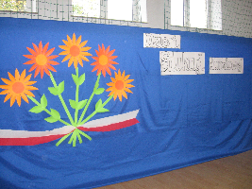

by Piotr Kupis and Jakub Jabłczyński

NATIONAL INDEPENDENCE DAY
11th November
National Independence Day is a public holiday in Poland. In 1918, after 123 years of captivity, our country regained its independence. We celebrate this day on 11th November every year.
In our school it is always a big event. We have prepared a lot of performances this year. Our students recited different poems and read a lot of information about that day. They sang patriotic songs. Everyone listened to these performances carefully and with emotion, and we liked them very much. We are proud that we are citizens of our country.
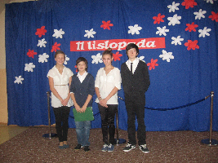
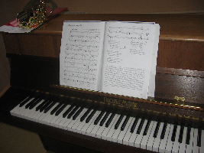

by Szymon Gawior and Dawid Jakubczyk



As everybody knows Christmas is coming... Poles with joy celebrate it with their family and friends. It occurs on 25th December every year. A day earlier, during Christmas Eve, we gather at a table to have Christmas supper. This holiday commemorates the birth of Jesus Christ in the stable in Bethlehem. When we hear “Christmas” we think about a nice decorated Christmas tree, snow behind the window and twelve dishes on the table, among other things the carp, a beetroot soup with ravioli, a poppy-seed cake and a prune compote. On Christmas Day we exchange Christmas greetings, we sing different carols, e.g.: "Today in Bethlehem" and "Silent night". Children are pleased with the gifts they find under the Christmas tree.
So…
We wish you on these exceptional days: a lot of happiness, love, enthusiasm for work on the Comenius project "The Voices From The Land" and plenty of gifts under the Christmas tree !
Merry Christmas!!!
 by Inga łukawska and Julia Sternak

ENGLISH IDIOMS & IDIOMATIC EXPRESSIONS
Ciekawe przysłowia i wyrażenia idiomatyczne w języku angielskim...


Wszyscy uczęszczamy do Gimnazjum w Kijach. Jesteśmy chwaleni, bądź otrzymujemy pisemne nagany. Mamy piątki, albo pały. Nauczyciele chcą nas jak najwięcej nauczyć, więc złoszczą się kiedy rozmawiamy na lekcji, albo wyrażamy arogancję wobec danego przedmiotu nie odrabiając prac domowych. Jednak Drodzy Nauczyciele, nasze występki da się wytłumaczyć. Oto tygodniowy harmonogram stosunku wobec nauki, losowo wybranego ucznia naszej szkoły. Co więcej najważniejsze hasła tego artykułu zredagowane są w formie międzynarodowego przekazu w języku angielskim.

MONDAY / PONIEDZIAŁEK
Wczoraj była niedziela. Jestem bardzo zmęczony wczorajszymi odwiedzinami krewnych, przejedzony słodkimi ciastami babci i przemęczony ogólnym lenistwem. Hasła dzisiejszego dnia:

To get behind with work. Zalegać z robotą.
To play a waiting game… on the lessons. Grać na zwłokę na lekcjach.
To get out of one’s duties. Wykręcać się od swoich obowiązków.
To take the line of least resistance. Pójść po linii najmniejszego oporu.
Not to give a damn! W ogóle się nie przejmować.

TUESDAY / WTOREK
No tak drugi dzień szkoły. Mam ochotę dziś pracować! Wczoraj sobie odpuściłem, ale dziś absolutnie, bo:

Slow and steady wins the race. Źródłem sukcesu jest przede wszystkim stała i regularna praca.
The sooner the better. Im prędzej tym lepiej.
To stir heaven and earth. Poruszyć niebo i ziemię.
To take trouble to do sth. Zadawać sobie trud, aby coś zrobić.
To take sth to heart. Wziąć sobie coś do serca.
Everything comes to him who waits. Cierpliwość jest kluczem do sukcesu.

WEDNESDAY / ŚRODA

Dzisiaj kolejny dzień w szkole. Nie mam co do niego konkretnych planów. Środa nie jest zła ani dobra. Środa jest neutralna.

To have a word with sb. Porozmawiać z kimś.
Sth goes on wheels. Coś idzie jak po maśle.

THURSDAY / CZWARTEK

Kiedy będzie weekend?! Strasznie dużo pracy! Mam tyle na głowie.

To be snowed under with work. Być zawalonym pracą.
Under sb’s orders. Pod czyimiś rozkazami.
To be on the rack. Cierpieć katusze.

FRIDAY / PIĄTEK


Ostatni dzień szkoły. W tym tygodniu już się napracowałem, więc dzisiaj mogę sobie odpuścić, a nawet trochę poszaleć. Czym mam się przejmować skoro, jutro weekend? Przecież po nim poniedziałek...... i tak nikt nic nie będzie pamiętał.

All work and no play makes Jack a dull boy! Nadmiar pracy sprawia, że człowiek staje się nudziarzem.
School is….. the game is not worth the candle. Szkoła to..... gra niewarta świeczki.
To be off one’s onions. Mieć bzika, być zwariowanym.

by Ewa Moskwa

Just kidding !


Krótka recepta na poprawę humoru po angielsku...

In the Morning Jasio is getting up and walking up to the window.
His mum is asking him:

-What’s the weather like today?
-I don’t know. It’s so heavy rain that I can’t see anything- the boy answers.

A little boy asks a driver:

-Could you give me a ride, please?
-But I’m heading in the opposite direction, son.
-Even better !

A:What do witches get in hotels?
B:Broomservice.

A: Why did the kid study in the airplane?
B: Because he wanted a higher education!

A: What did you learn in school today?
B: Not enough, I have to go back tomorrow!
Coming in the next issue
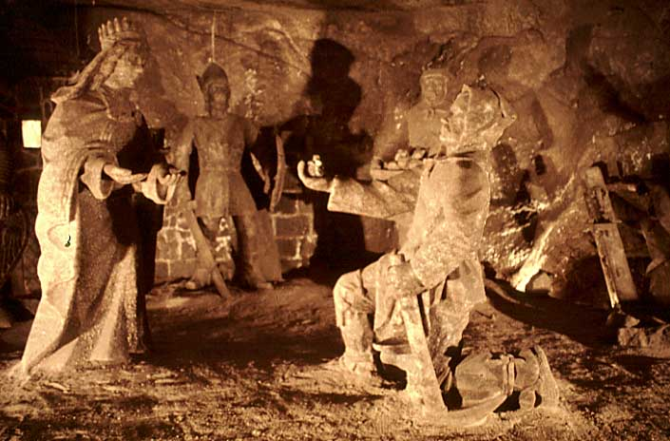

Wieliczka – an underground kingdom
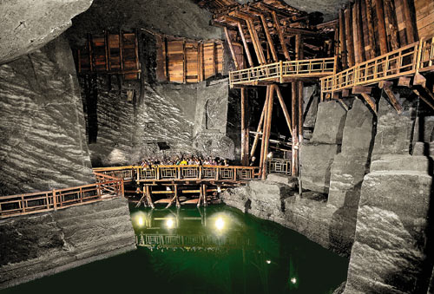

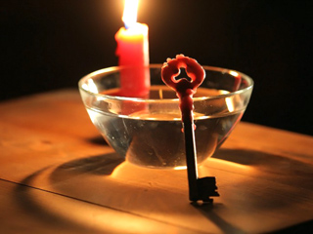
St Andrew’s Eve party
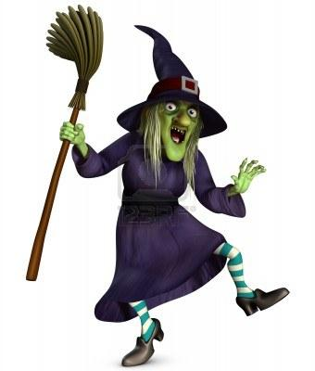


Christmas wishes



See You soon!

