Italian cookery is famous in all over the world and at Christmas there is also a wide gastronomy. Another Italian tradition is the Christmas Eve dinner.
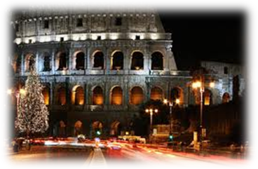
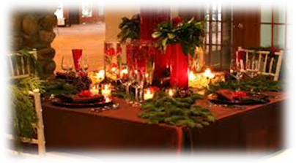
Italian Christmas food

We can find lots of typical food on Italian tables on Christmas Eve and on Christmas Lunch. Usually on Christmas Eve the menu is seafood but on Christmas Lunch the menu is more various. Some of the typical food are desserts. The most famous are: Panettone, Pandora and Nougat. Panettone is the most typical food: it’s made with flour, eggs, butter, water and sugar with the addition of citron and orange’s candied and raisin. Pandora has the same dough of Panettone, but it isn’t garnished with candied and raisin: it is served with icing sugar. The other dessert is Nougat. It’s made with eggs, sugar and honey stuffed with almonds or nuts and recovered with two hosts.

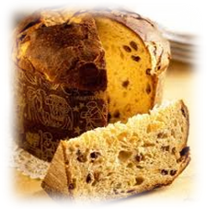

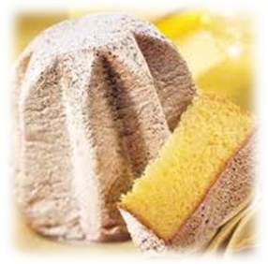

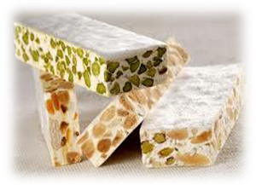

There are some other desserts in Italian Christmas. These are less famous than other but they are also very important in Christmas food. These are: Cartellate, Struffoli and Panforte. Cartellate are similar to some roses: they are strips of dough rolled up and topped with cooked wine and colored sprinkles. Struffoli are a typical Neapolitan food. Struffoli are little balls of dough garnished with honey and, like Cartellate, with colored sprinkles. Then there is panforte. It has a low and round form. It’s made with sugar, flour, almond and candies.

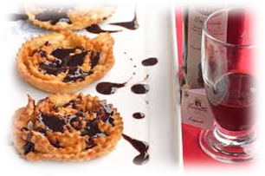

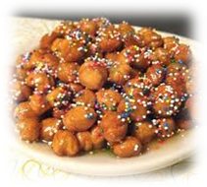

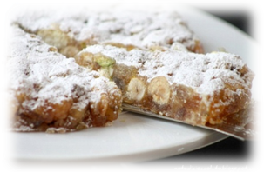

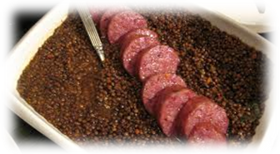
There aren’t just desserts… there are also other types of food like pork sausage with lentils: it’s a very tasty type of meat usually accompanied by lentils, as tasty as pork sausage.
4

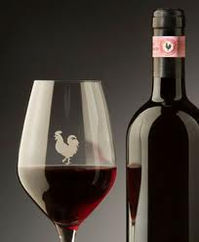
Of course, on Italian Christmas, you can’t miss Italian Wine, like Chianti….
5

